CODING ACTIVITY 2.3 SOLUTION

Task

Open the equals-operator-01 folder, follow the instructions to work in the task.

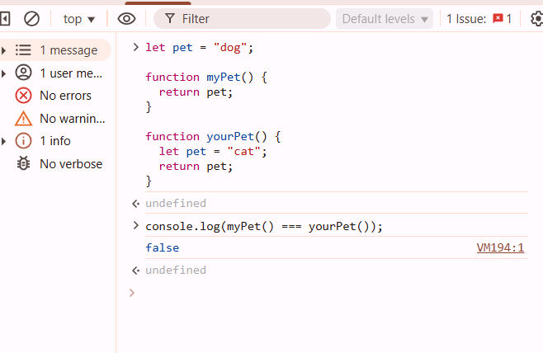

Task

Create the function getPlayingStyle, return the team you think it has the best playing style.

